Git and Github

Git Workflow
* Untracked
* Tracked
*Staged
*Commit

Repository
* Storage location for your code and its history.
* Can be local or remote.
* Tracks all changes to your project files.

Working directory
*Location where you work on your code.
*Changes made here are not yet saved in Git's history.

Local repository
* The version of the repository stored on your computer.
* You use it to make commits and view the version history.
* The version of the repository stored on platforms like GitHub.
* Used to share your work with others or collaborate on projects.

Git Workflow
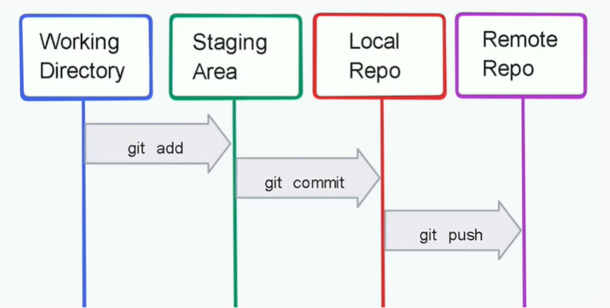

create a new repository on the command line
echo "# Git-workflow" >> README.md
git init
git add README.md
git commit -m "first commit"
git branch -M main
git remote add origin https://github.com/isave35862-netizen/Git-workflow.git
git push -u origin main
…or push an existing repository from the command line
git remote add origin https://github.com/isave35862-netizen/Git-workflow.git
git branch -M main
git push -u origin main

Git ignore

The .gitignore concept in Git is all about telling Git which files or directories it should not track in your repository. This helps keep your project clean and avoids committing unnecessary or sensitive files.
- Hevy folder we shouldn’t be store
- That folders we want to keep in working dir but not in github.
- Which contains sensitive data

